- First Trigger Example – AFTER INSERT
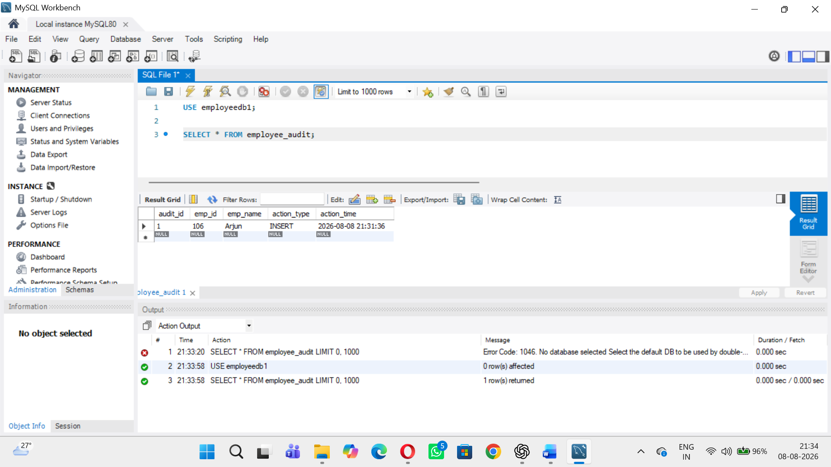
- Second Trigger Example – AFTER DELETE
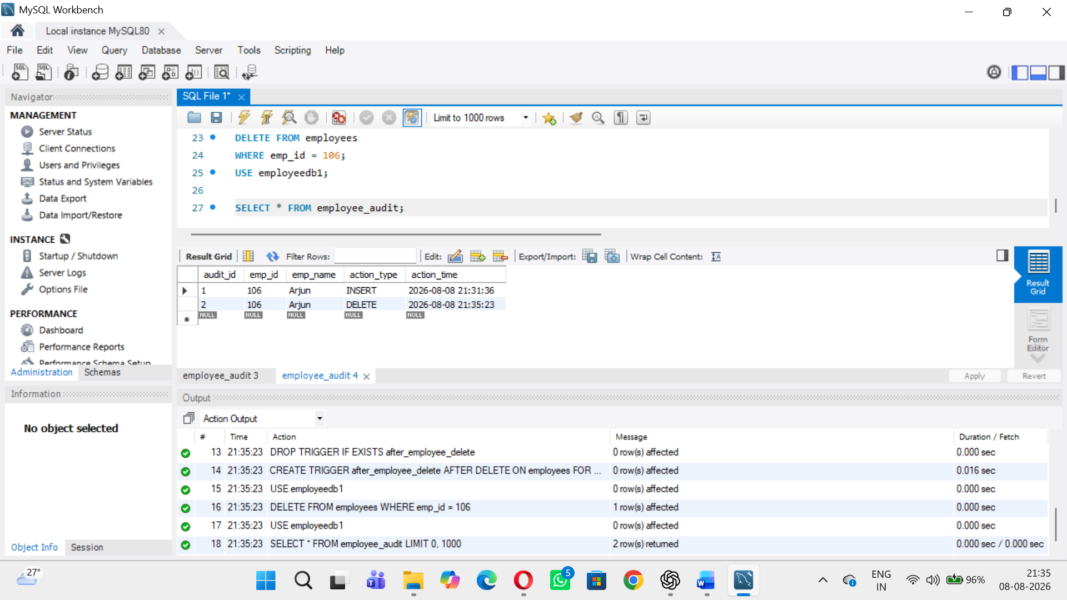
- Third Trigger Example--AFTER UPDATE Trigger:
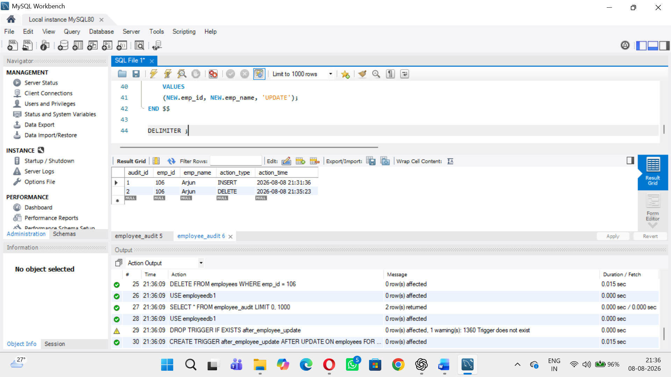
- Fourth Trigger Example--BEFORE INSERT Trigger:
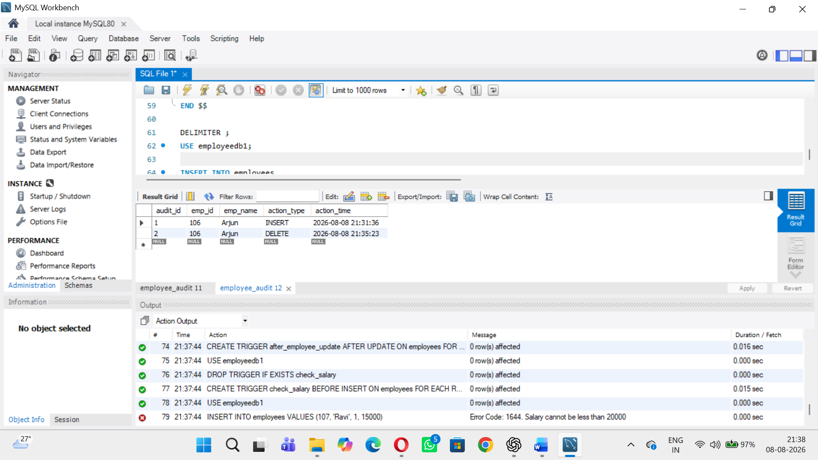
- Fifth Trigger Example--BEFORE UPDATE Trigger:
